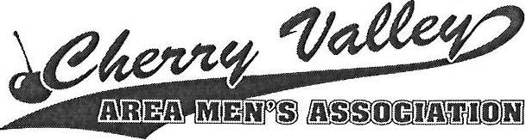

Student Scholarship Application

The following application is for the Cherry Valley Area Men's Association Scholarship Award. Applicants who meet the eligibility requirements stated below are encouraged to apply.

Rules and Requirements for Applicants

This Scholarship Award for the amount of $500.00 is to be used for tuition and books toward an accredited college degree program. This Award must be used for the fall ________semester and/or spring _______.

Applicant must be a graduating senior attending a Winnebago County or Boone County school or attending an accredited College/University.

Scholarship will be awarded on the basis of applicant's demonstrated scholastic achievement, financial need, and volunteer service to family, school, and community.

Chosen qualified applicants may be asked to interview with CVAMA committee.

Applicant must submit one letter of recommendation from a teacher, counselor, or employer.

The completed application must be returned in an envelope clearly marked "Scholar ship Application" .

MAIL TO: Tom Larson

Youngberg Industries

6863 Indy Drive

Belvidere, IL 61008

Applicant Name: -----------------------------------------------
Last First Middle Initial
Permanent Address: _______________________________________________
Address

-------------------------- Date of Birth: _________________________
City/State/Zip

Parent/Legal Guardian: _____________________________________ Phone No.____________________

What school are you currently attending/planning to attend?

City/State/Zip County
What will be your enrollment status? Check one Full-time ___ Part-time __
What will be your degree/certificate? ---------------------------- Course of study: __
List two (2) references (Personal or Teacher):

Name | Position | Tele # (home) | Tele# (work)
Name  Employment (if applicable) | Position | Tele # (home) | Tele# (work)
Employer's Name | Address | Phone | Hours/Week
(Please attach a sheet if more space is necessary to answer the following questions)
How critical or helpful will monetary scholarships be in your quest for a college degree?

To what extent have you been involved in extra-curricular activities at the high school level? List any activities, honors, and offices held.

Tell us about your commitment, in terms of time and talent, to community service.

I attest that all information is complete and accurate.

Applicant’s Signature Date
* Please make sure you have submitted all necessary requirements as listed on page one *

